Download Manager How-To **Earthdata Bulk Downloader**

short line

August 28, 2020

# Getting Started

Once the extension is installed in your browser, make sure to pin the extension in the toolbar, if you don’t see it there. Select the extension logo as highlighted by the red square, and click on the pin icon beside the EarthData Bulk Downloader extension option as shown by the arrow.

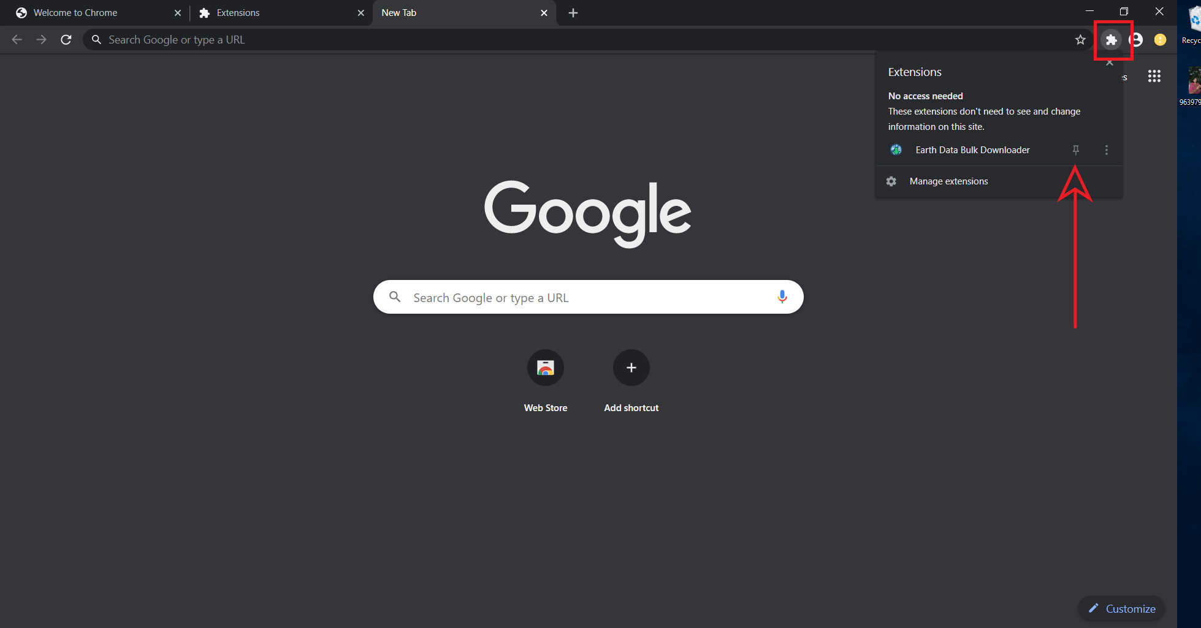

Now, click on the Bulk-Downloader Logo to see the pop-up window or the download manager UI.

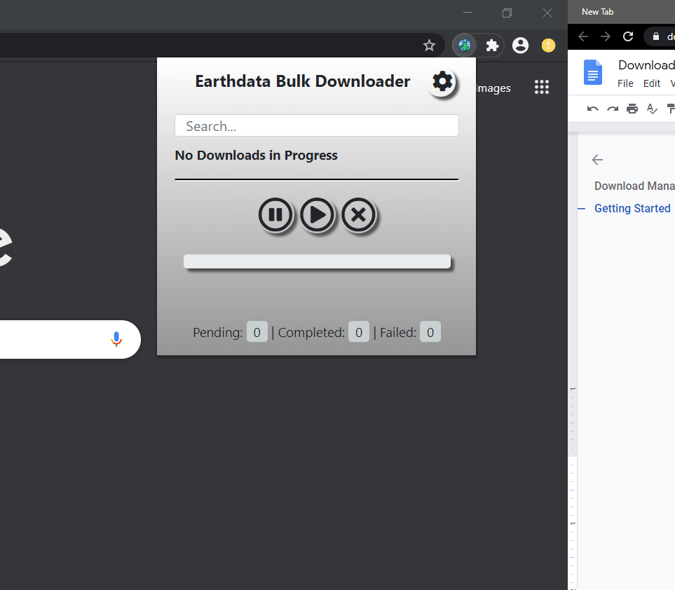

# Features

The Bulk Download Download Manager has the following features.

* Pause/Resume/Cancel Buttons
* Progress Bar
* Download Statistic
* Setting
  + Edit Folder Name
  + Show Downloads
  + Clear pop-up

Let’s go through them one by one.

# Pause/Resume/Cancel

The location of the pause/resume/cancel buttons can be seen in the screenshot below as highlighted by the red rectangle.

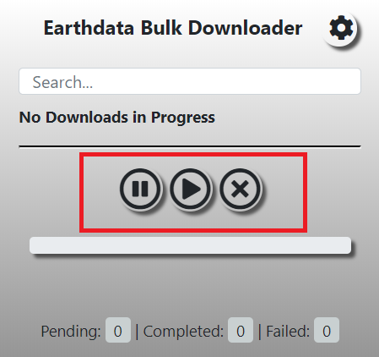

The buttons work as expected. The first button from the left is the pause button, which can be used to download ongoing downloads. If there is a paused download job, the center button, or the resume button can be used to resume the downloads.

The cancel button, however, works a little bit differently. To cancel an ongoing download, select the cancel button, the rightmost button, with a cross icon. On clicking the button, the downloads are temporarily paused and a dialogue box appears asking for a confirmation.

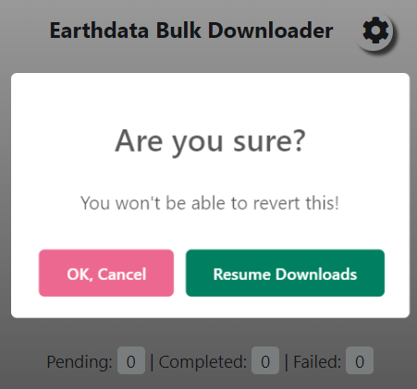

If you want to revert to downloading, simply click on the “Resume Downloads” button. To confirm canceling the downloads, click on “OK, cancel”.

# 

# Progress Bar

The progress bar keeps track of the completed downloads out of the total downloads and returns the percentage of downloads completed. In the image below, the progress bar is highlighted by the black bounding box.

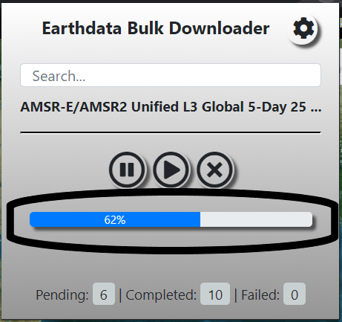

# 

# Download Statistics

In addition to the progress bar, we can take a look at the download statistics of the download job. We can see the name of the dataset along with the statistics. The statistics include pending, completed, and failed count.

* The pending count tells us the number of granules that haven’t started yet or have started but haven’t completed yet
* The completed count tells us about the number of granules that have been completed and are ready for use
* The failed count tells us the number of granules that couldn’t be downloaded.

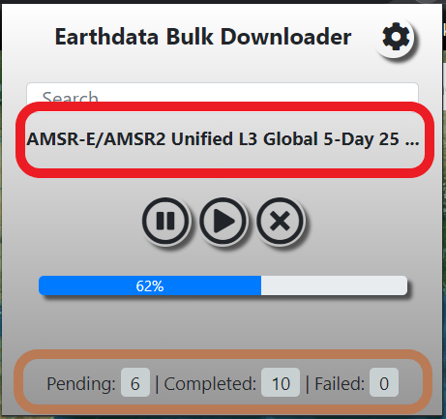

# Settings

The settings option drops down the following three features for us. It is the gear icon located at the top right corner of the pop-up window.

* + Edit Folder Name
  + Show Downloads
  + Clear pop-up

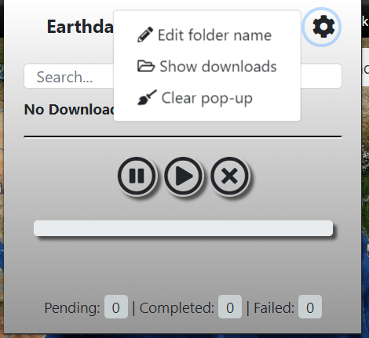

## Edit Folder Name

All the downloads completed by the extension currently goes to a folder called “Earthdata-Bulk Downloads” in your default download folder. Edit folder name option lets you rename the folder name.

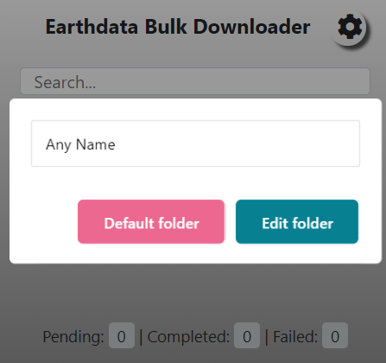

On clicking the option, a dialog box will appear where you can type the folder name and select “Edit Folder”. You can cancel this dialogue box by clicking “Default folder” and it reverts back to the default folder name.

## Show Downloads

Show downloads option opens the default download folder. This feature is handy if your default download location isn’t the “Downloads” folder or you don’t remember it.

## Clear Popup

As we saw above, upon download, the progress bar, download statistics and dataset names are displayed in the pop-up window. We can clear those logs from the pop-up by selecting the “clear popup” option.